LAB Logbook

Lab 1
Week1-LinearRegression_tensorflow
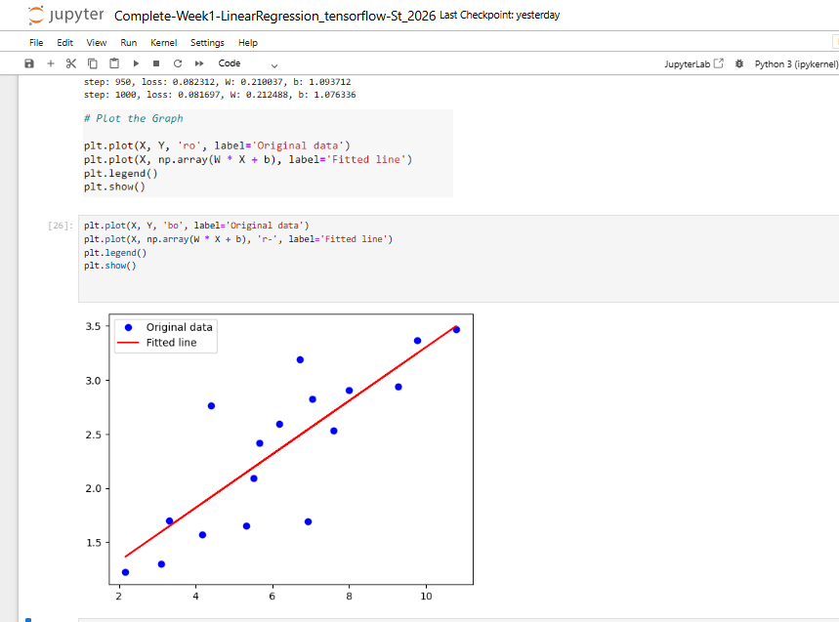
Week1-Complete-TensorFlowBasics
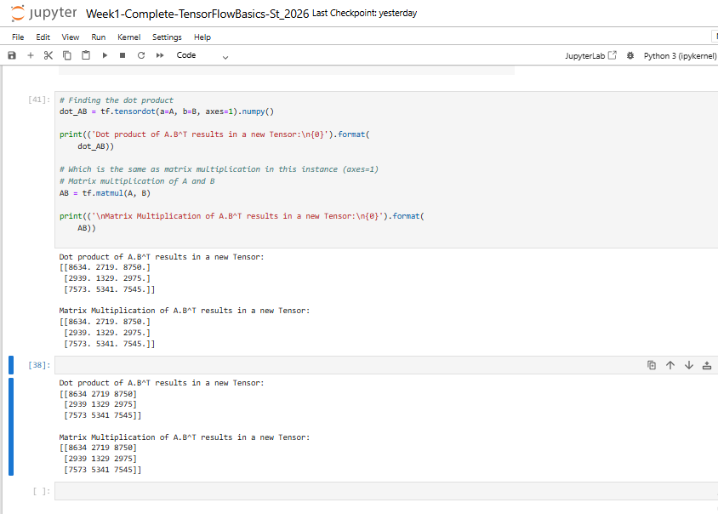

Lab 2
Week-2 MLP
Accuracy is “0.98”
MLP architectures
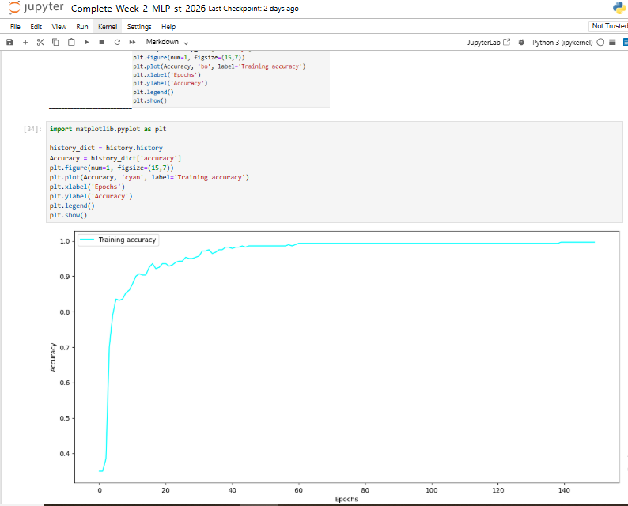

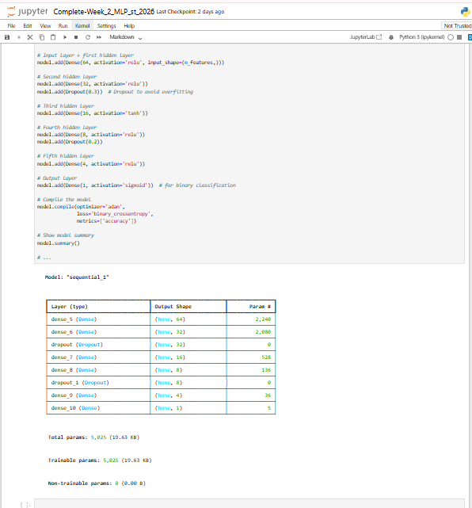

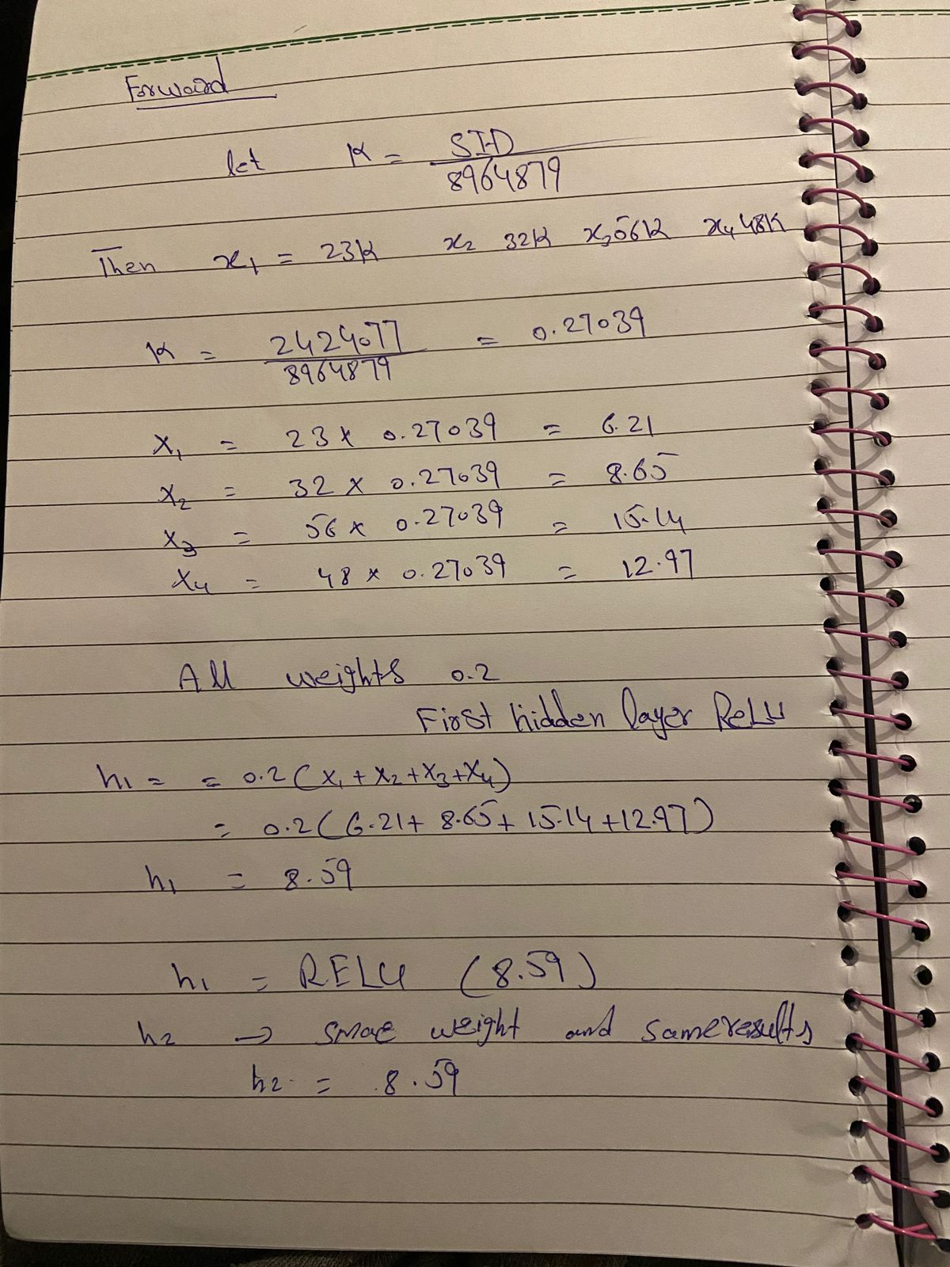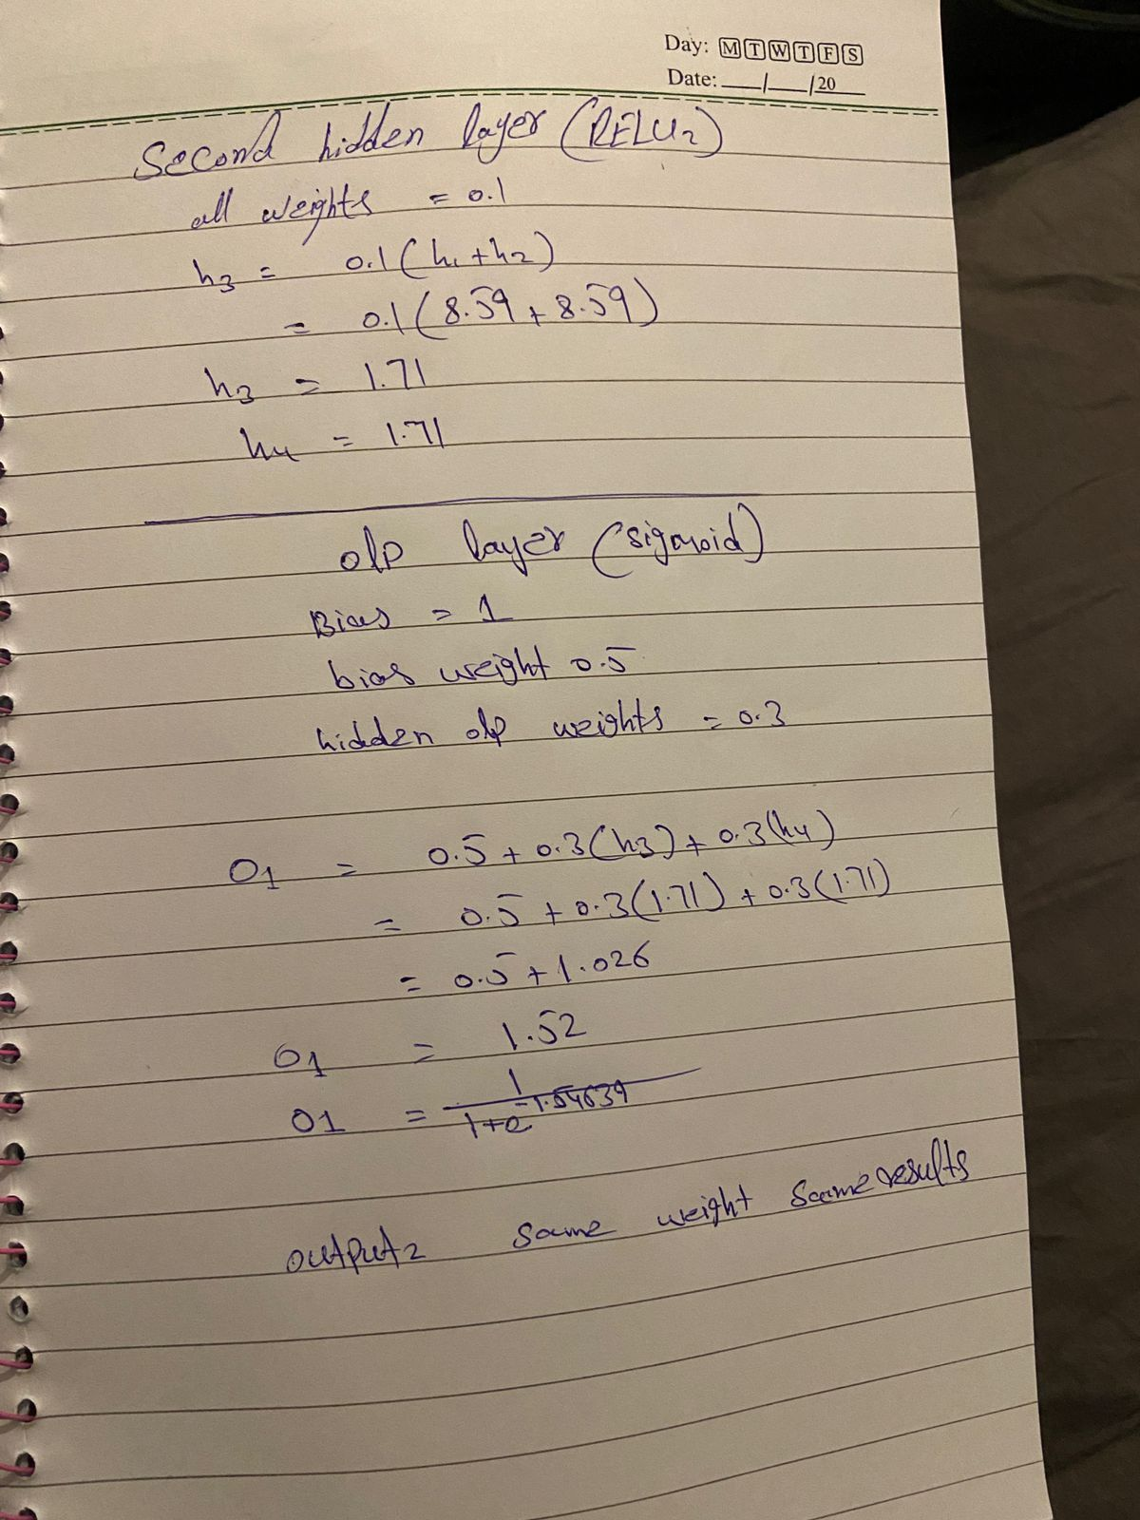

Lab 3

Lab 4

Lab 5

Lab 6

Lab 7

Lab 8

Lab 9

Lab 10

Lab 11

Lab 12

